

# TASK 1: New Zealand HealthCare System…

The application below is designed for the NZ HealthCare system. Where a patient can book appointments to meet the doctors and HealthCare staff can access features of the application according to the role or department they belong to.



Above is shown the login page of the NZ HealthCare Application.

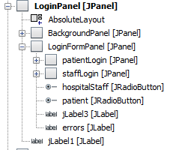

Login page is broken into multiple sections consisting of several panels.

But what we are mainly focusing on will be he 2 JPanels below LoginFormPanel (JPanel). Those are patientLogin(JPanel) and staffLogin(JPanel).

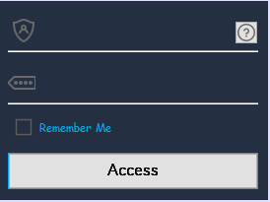

This is what patient login looks like by itself, it contains 2 JLabels, 2 JTextFields, 2 JButtons and 1 Checkbox. It also has 2 separators (the white lines you can see are the separators I’m talking about.

You might be unable to see JTextFields and JLabels, as for textfields I have removed their border and set their background colour same as background to make it more moderate. And as of JLabels, you can see those icons infront of invisible textfields, those are the jLabels.

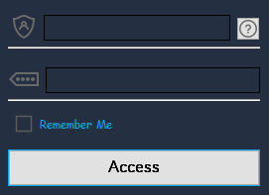

Here in this screenshot you might be able to see the JTextFields.



To change the border and make it invisible, select your JTextField and from the properties click on … at the end of border.

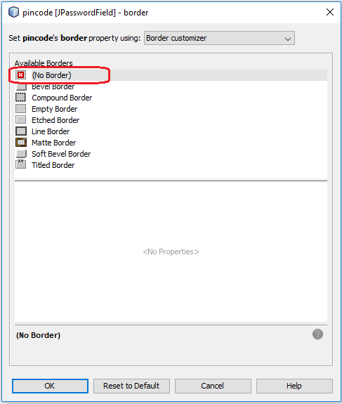

Select (No Border) and click OK.



You can change the background of your JTextField to match the colour of your application.

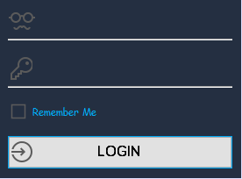

Staff Login is designed the same way.

Before we begin adding any functionality to our login form, we need to setup connection between out application and the database server, for this application we are using localhost server.

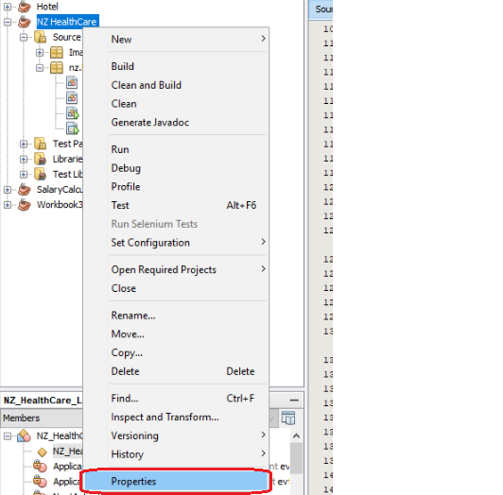

So, go to properties of your project, but right clicking it and selecting `Properties`.

Select Libraries

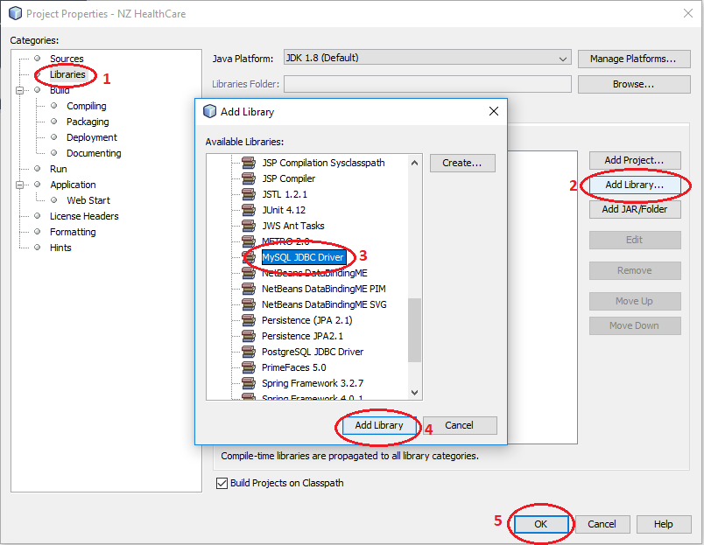

Click on Add Library, look for MYSQL JDBC Driver, and click Add Library and press ok to save it.

For the last step we need to setup our database.

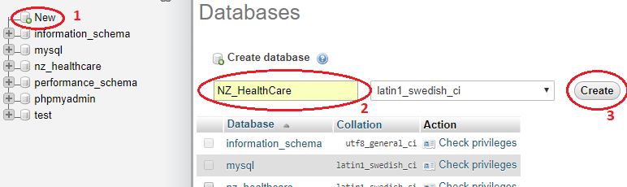

Install Xampp, Mamp or Wamp. Any of these 3 tools can be used as they work the same way.

Once you have installed it, run it and then open your browser and go to: <https://localhost/phpmyadmin>

Here click on New on the left panel of the phpMyAdmin page. By pressing new you are asking phpMyAdmin to create new Database for you, after that enter the name of your database and press create.

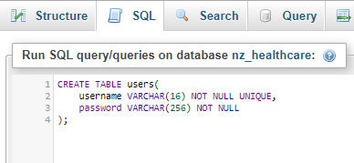

Once you have your database created go to SQL tab and run this same script.

Now, finally we can start with the coding section of our application.

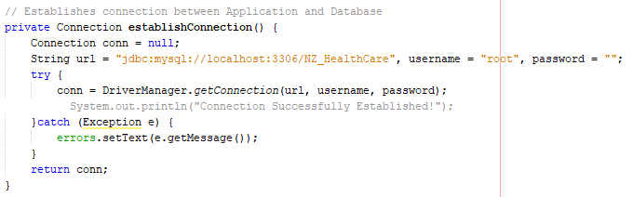

The code above is used to establish connection between the server and your application.

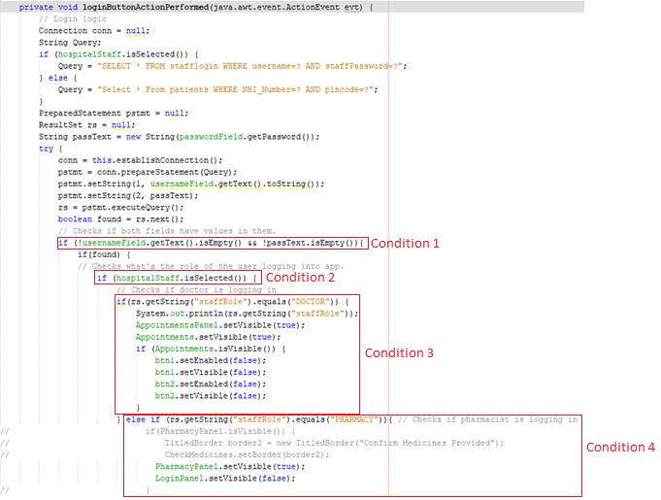

At condition 1: It checks if both username and password are entered and none of the above fields are empty.

At condition 2: We are determining if the user who wants to login belongs to hospital staff or not.

At condition 3: if we are logging in as hospital staff we are checking if the user who is logging in is a Doctor.

At condition 4: we check if he’s not a doctor then is he part of pharmacy department.

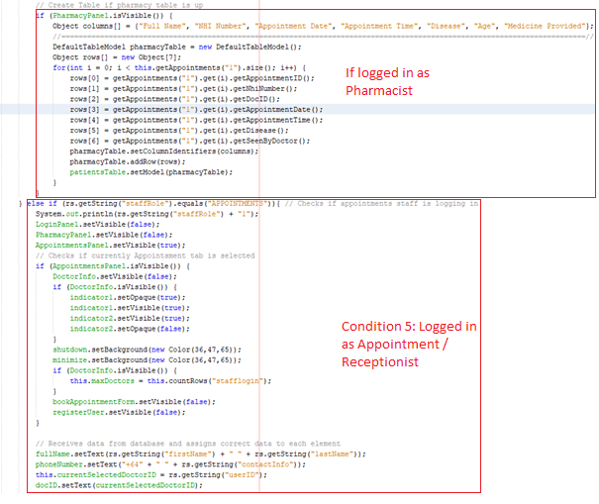

If the user is logged in as part of pharmacy department, then it’s creating a new table with columns listed above in columns[] array.

And after that with the help of for loop it’s sending the data to rows.

At condition 5: checks if user belongs to receptionist department.

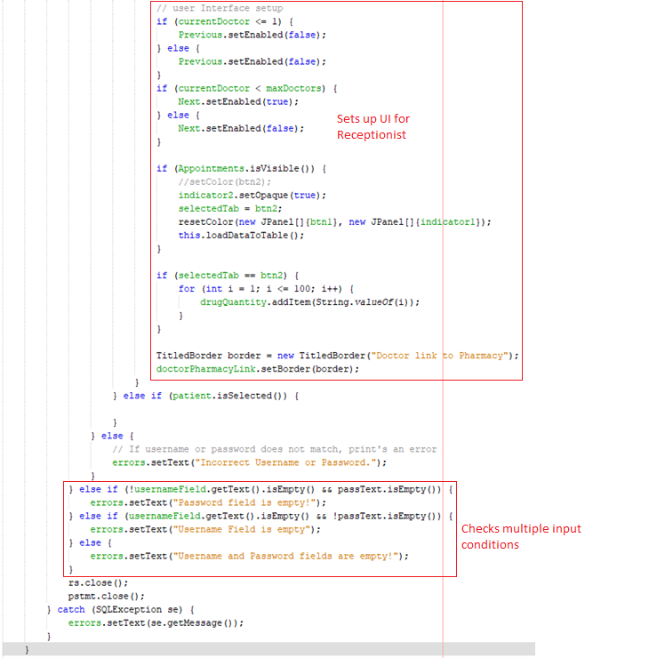

If user belongs to receptionist department, then it get’s the list of all doctors with their detailed information, and receptionist can book an appointment accordingly depending on which doctor is best suited for your needs.

All the code above is used to make a successful login system for your application, it’s not secure enough but for the time being it’s something good enough to work with.

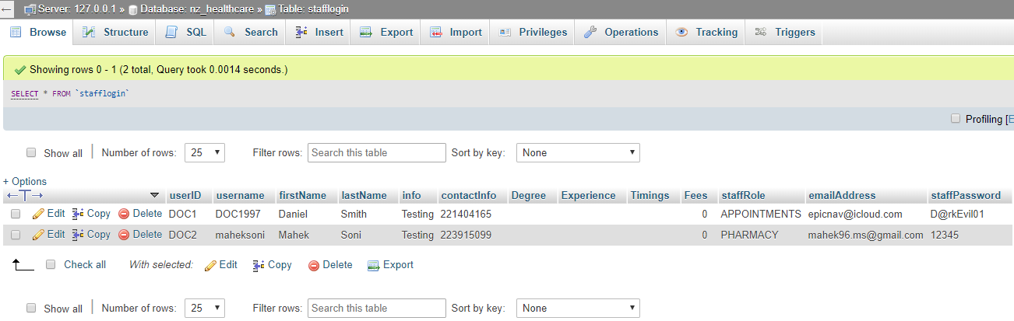

This is the list of staff that exist In our database and depending on which role they are in the can access their specific departments in the NZ HealthCare application.



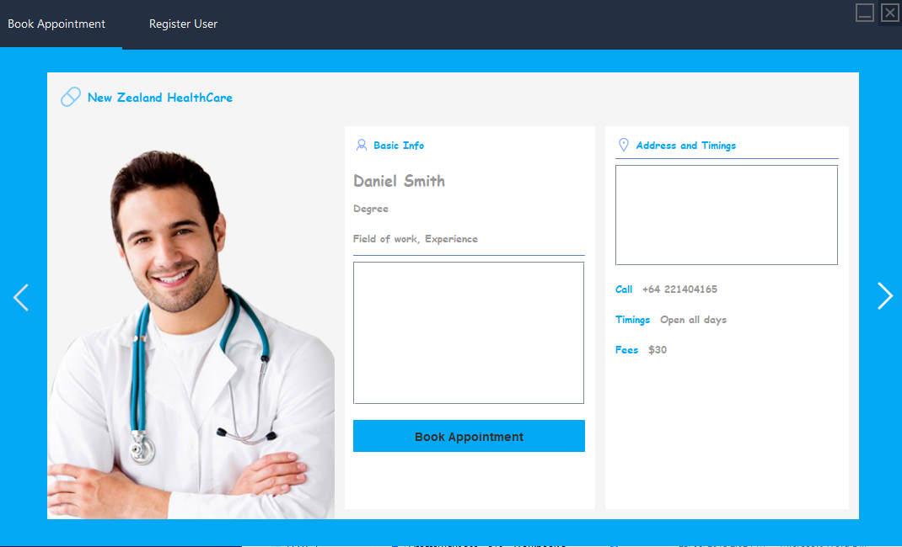

If you belong to the “**APPOINTMENTS**” Role, then you will be directed to appointsment booking page where you can book appointments for the patient.

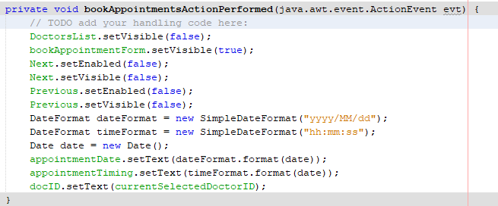

This chunk of code is executed, when you press ‘Book Appointment’ button.

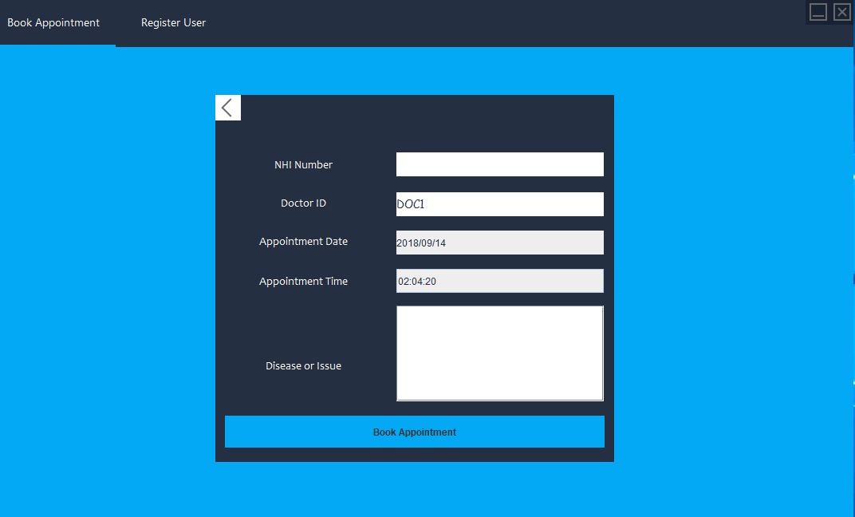

New appointments for patients can be booked from this page.

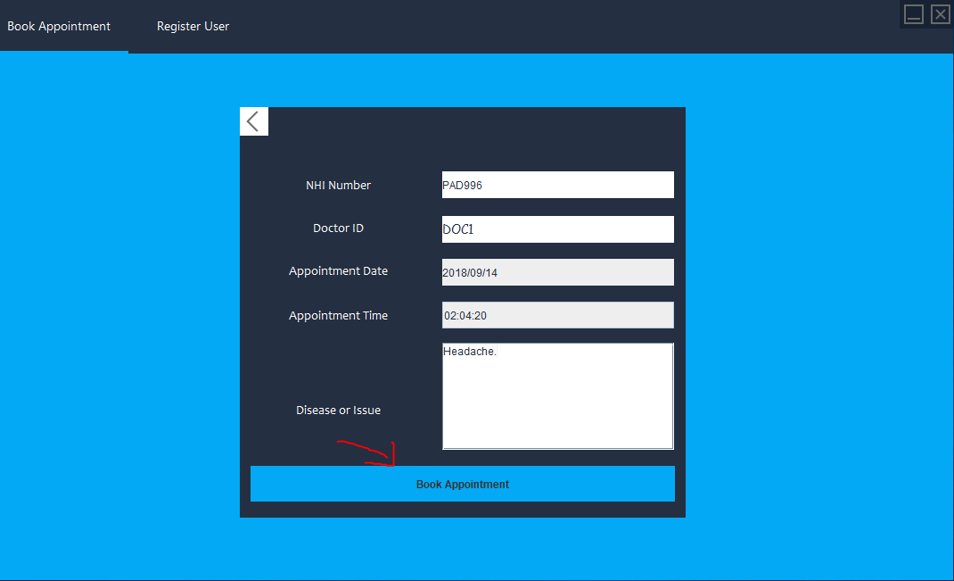

Here we are booking a new appointment for a patient.

Note: Before we can book an appointment, a patient should be registered with the New Zealand HealthCare.

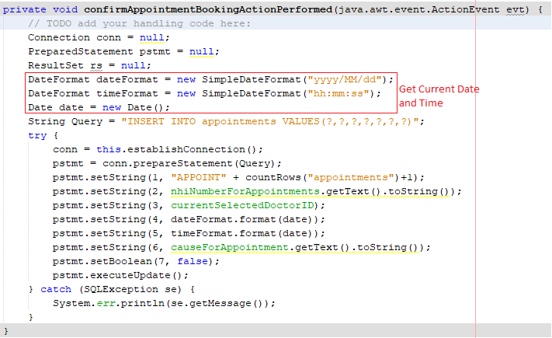

To ‘Book Appointment’ the code above is executed as it sends data to our database.

The part highlighted in the screenshot, is to get the current date and time and convert it into the given format.

**“YYYY/MM/DD”** = This format is for **YEAR/MONTH/DATE (2018/09/14)**

**“hh:mm:ss”**  = This format is for **Hours:Minutes:Seconds (10:30:10)**

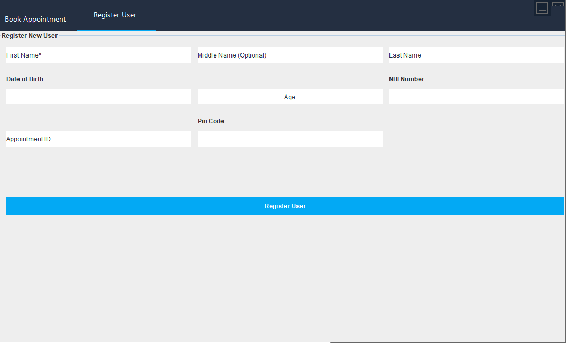

From the **“Register User”** tab you can register new patients with New Zealand HealthCare before they can book appointments. (Note: This step is to be taken only for the patients who are visiting New Zealand HealthCare for the first time.

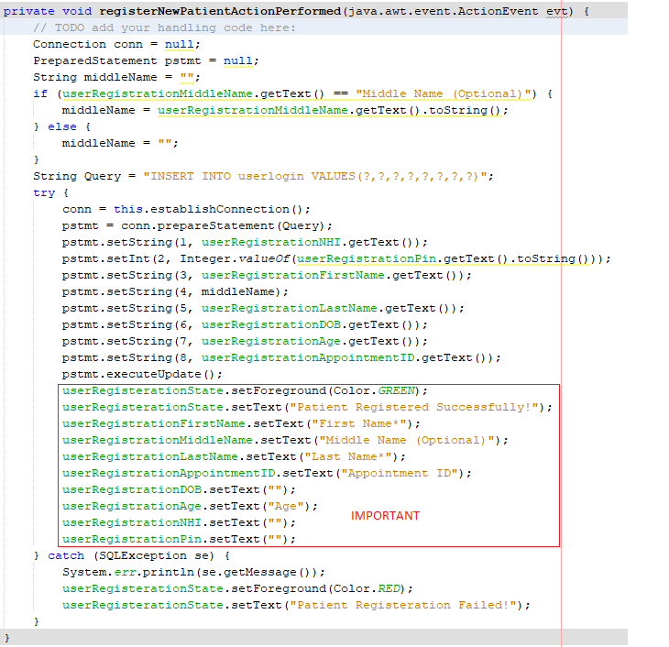

Code above is used to successfully register user with the hospital and add their information to our database.

(IMPORTANT: The code marked important is used to reset all the fields back to empty or what their usual placeholder is).

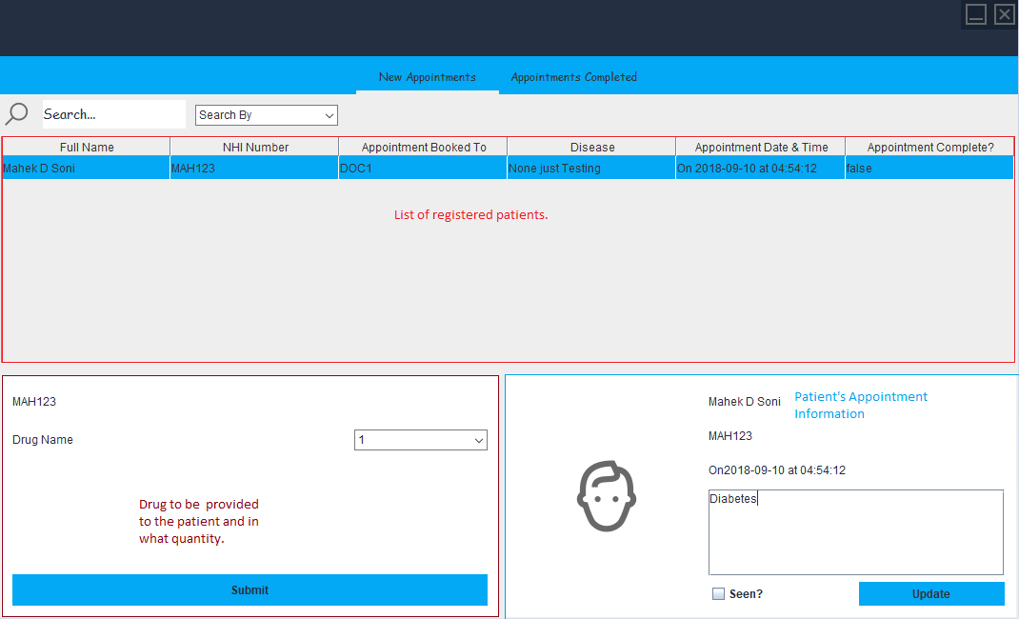

All the patient’s who are registered to the doctor who’s is logged in will be listed in the list of registered patients.

In the Patient’s Appointment Information, details of patients appointment, i.e Appointment time, date, patient’s NHI Number, Patient’s Name etc will be displayed for the patient selected in patient’s list.

What drug patient needs to be provided by pharmacy can be added through drugs tab.

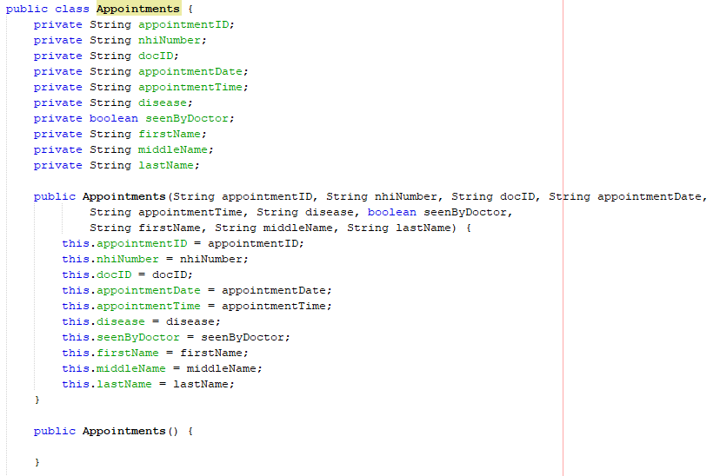

For this purpose we had to create a new class of appointments to create an array list where we could store the list of all appointments that we get from our database.

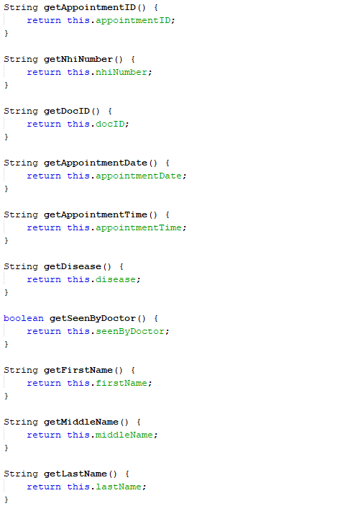

And then create the getters for all the private variables we created above.

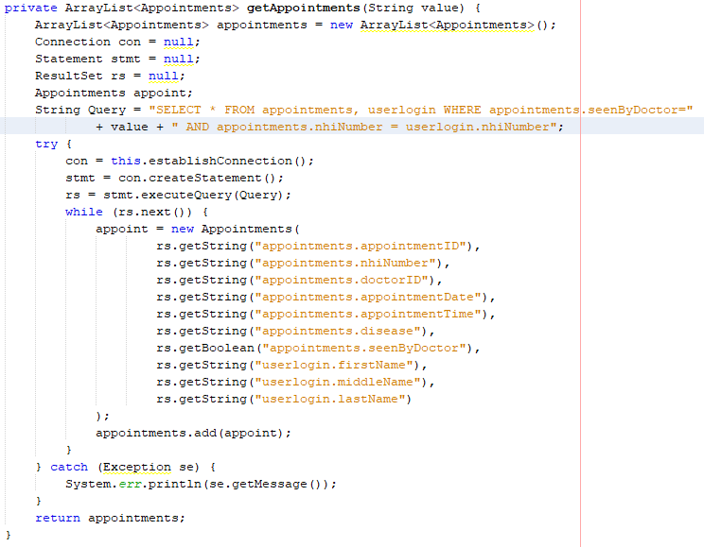

This is a private variable of return type **ArrayList<Appointments>** the new class we created earlier.

The **<Appointments>** in corner brackets next to ArrayList is the type of array list, and that Appointments type belongs to our Appointments Class that we created earlier.

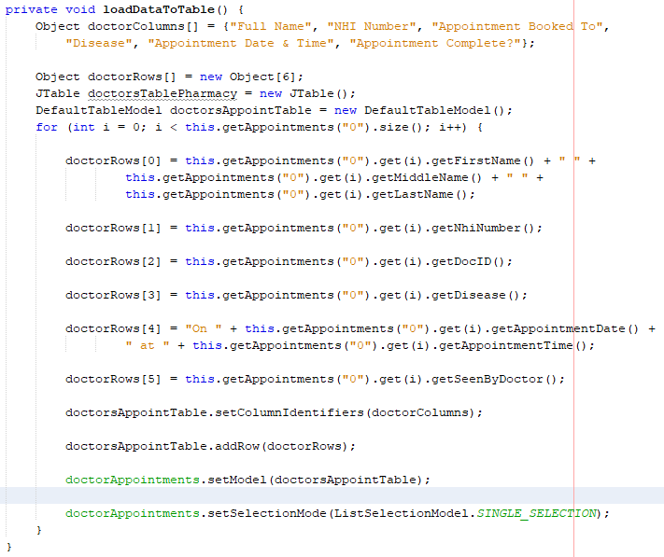

Here we are loading data from the database from appointments tab and then adding it to our arraylist.

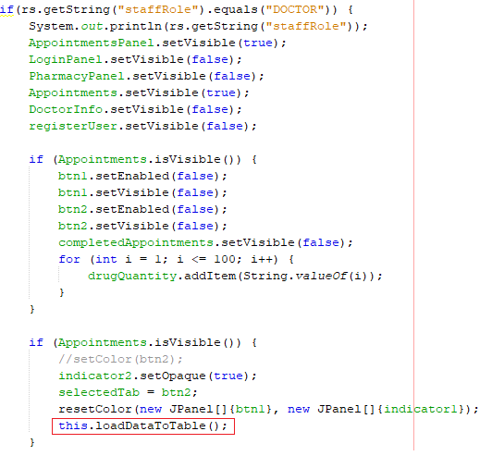

Once the data has been **this.loadDataToTable();** is used to execute the functional and display the data added to the tables. Unless this method is called the data won’t be visible in the tables.

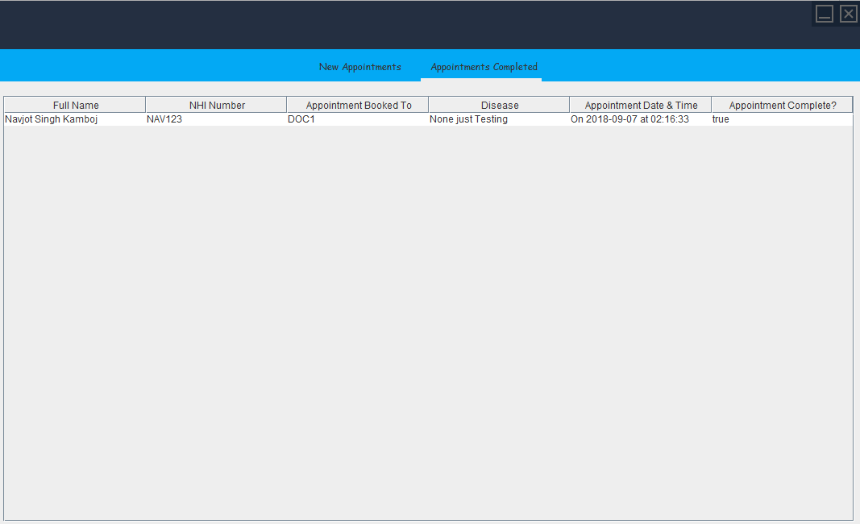

In this tab, all the appointments that have been completed by the doctor are displayed.

SO NOW THE FINAL STEP THAT’s LEFT IS TO HANDLE AND WORK WITH PHARMACY

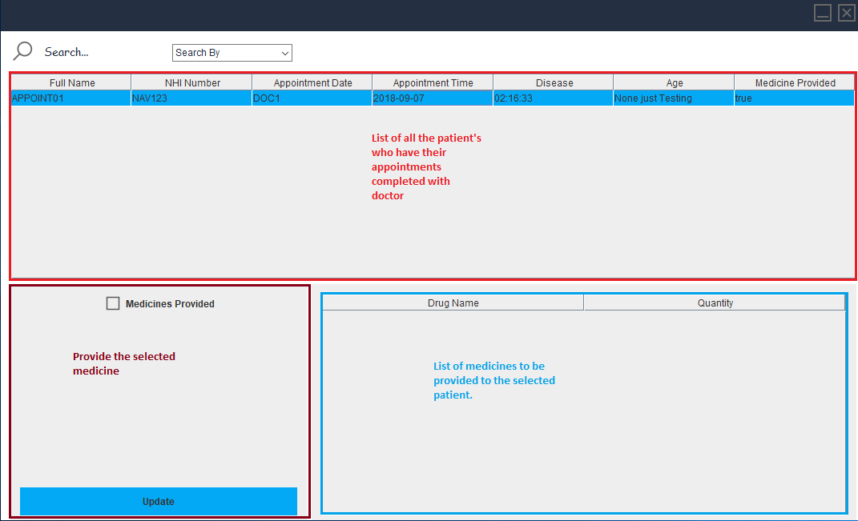

In the first table list of all the patient’s who have their appointments completed with doctor are listed.

In the table on bottom right corner, contains all the drugs and quantity of that particular drug for the selected patient which have not been provided yet.

At last there is a checkbox called Medicines provided, and Update button, once the medicine has been provided it will update the database and mark the medicine provided as true.

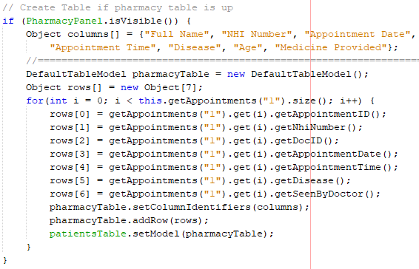

With this line of code we are getting list of all the patients who we have their appointments completed with doctor.

And adding it to table.

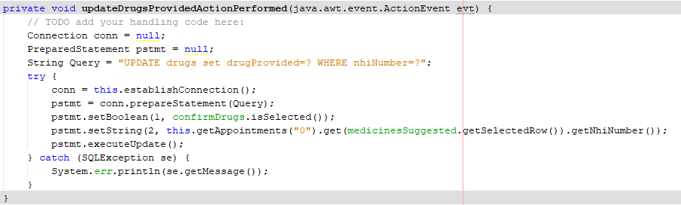

With the code above we are updating the drug selected from the list of drugs and setting it as provided.

# TASK 2: Age requirements for activities Application…

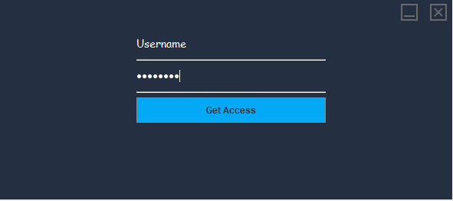

Login page for the age requirement application, which gives you access to all the internal features of the application.

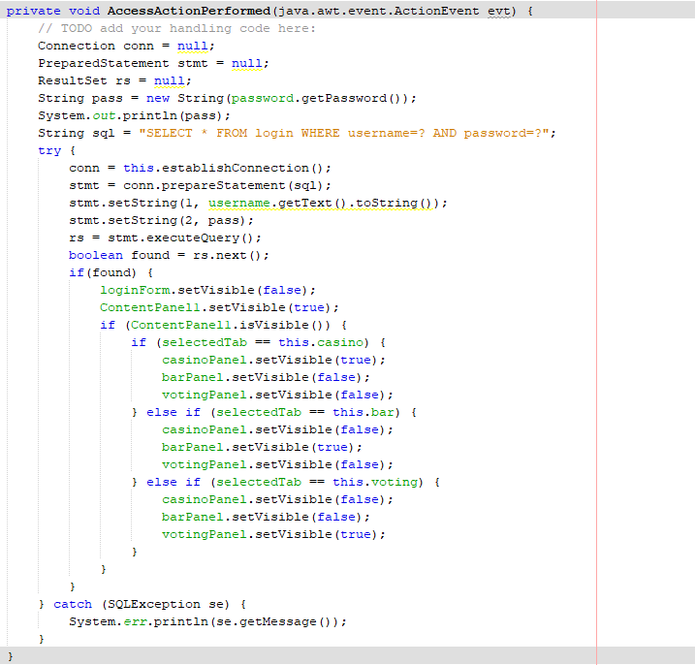

The following code is used to make a login page functional.

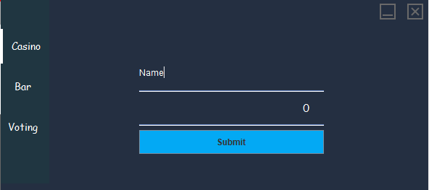

Before you can get entry to any of the three places there if age requirement that needs to be met, if your age doesn’t meet the requirement you cannot gain entry.

## CASINO

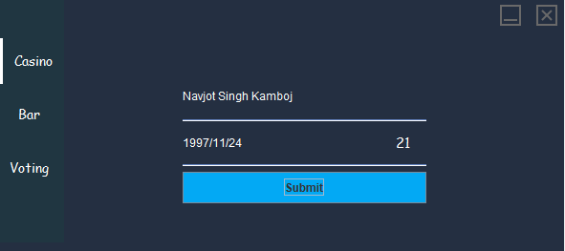

My age is displayed 21 Y/O after I entered my DOB.

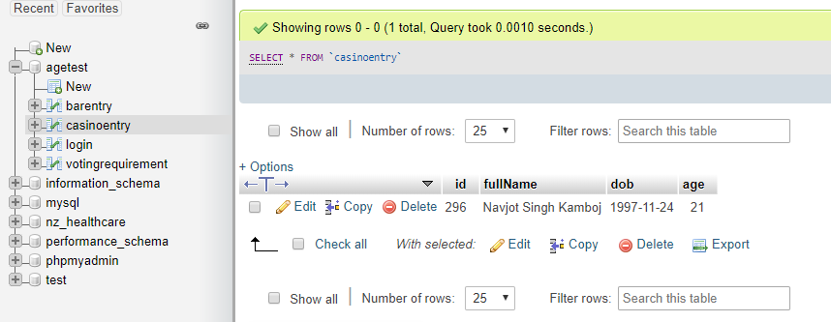

After that if I check the database I have gained entry to the casino.

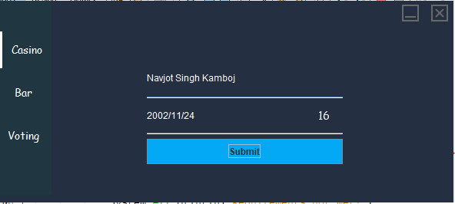

Not that I tried it by changing my DOB and making myself 16 Y/O it declined my entry with an error message shown below.



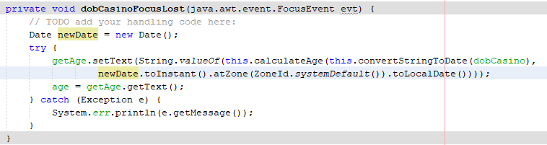

There are some custom functions used that calculate age, shared below:

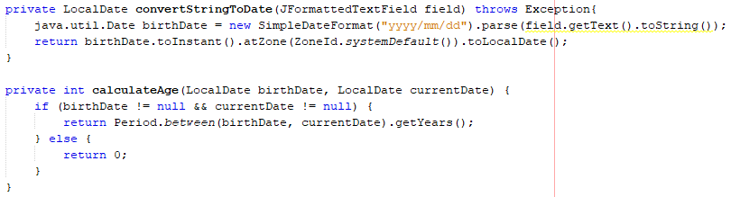

The code below is used to insert data to database.

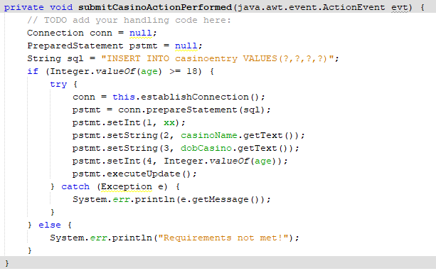

## BAR

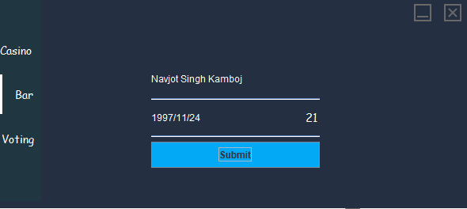

The same functionality as above as the casino is used for Bar and voting.

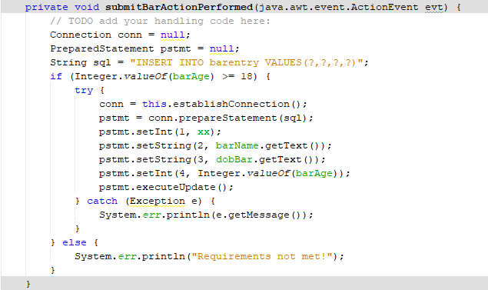

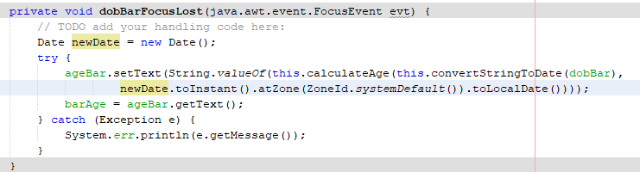

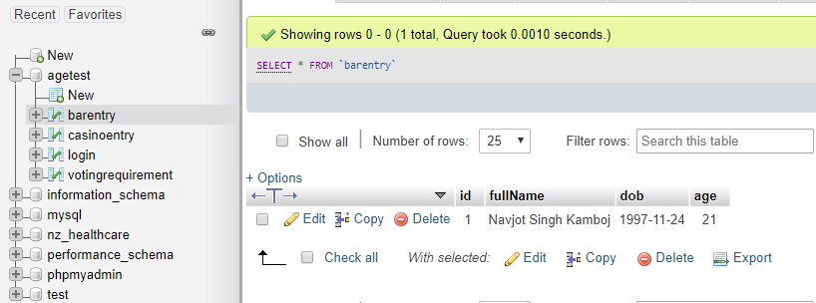

## VOTING REQUIREMENT

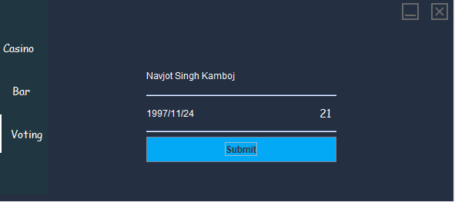

Again the same functionality as Casino and Bar is used for Voting Requirement.

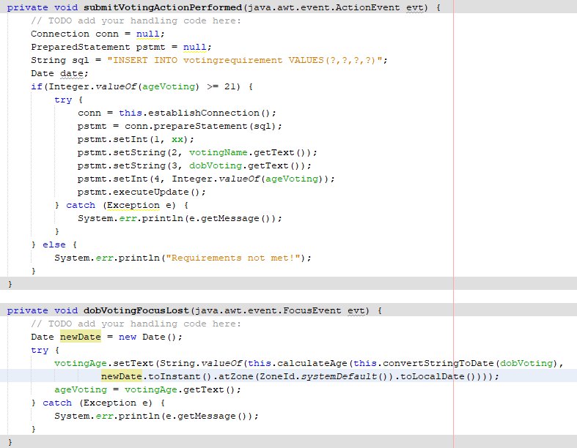

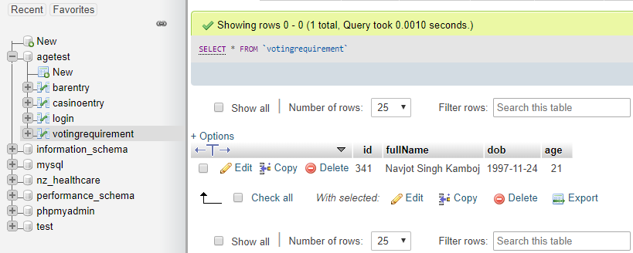

The data here has been successfully added to VotingRequirements Table.

# New Zealand HealthCare: Web Application



This is the webpage of NZ HealthCare.